### !a) Describe the dataset
library(MASS)
data(crabs)
str(crabs)
summary(crabs)
Output:
> summary(crabs)
sp sex index FL RW
B:100 F:100 Min. : 1.0 Min. : 7.20 Min. : 6.50
O:100 M:100 1st Qu.:13.0 1st Qu.:12.90 1st Qu.:11.00
Median :25.5 Median :15.55 Median :12.80
Mean :25.5 Mean :15.58 Mean :12.74
3rd Qu.:38.0 3rd Qu.:18.05 3rd Qu.:14.30
Max. :50.0 Max. :23.10 Max. :20.20
CL CW BD
Min. :14.70 Min. :17.10 Min. : 6.10
1st Qu.:27.27 1st Qu.:31.50 1st Qu.:11.40
Median :32.10 Median :36.80 Median :13.90
Mean :32.11 Mean :36.41 Mean :14.03
3rd Qu.:37.23 3rd Qu.:42.00 3rd Qu.:16.60
Max. :47.60 Max. :54.60 Max. :21.60

1b)
# Load the MASS package
library(MASS)

# Load the crabs dataset
data(crabs)

# Display the structure of the dataset
str(crabs)

Output:
# Load the crabs dataset
> data(crabs)
>
> # Display the structure of the dataset
> str(crabs)
'data.frame': 200 obs. of 8 variables:
$ sp : Factor w/ 2 levels "B","O": 1 1 1 1 1 1 1 1 1 1 ...
$ sex : Factor w/ 2 levels "F","M": 2 2 2 2 2 2 2 2 2 2 ...
$ index: int 1 2 3 4 5 6 7 8 9 10 ...
$ FL : num 8.1 8.8 9.2 9.6 9.8 10.8 11.1 11.6 11.8 11.8 ...
$ RW : num 6.7 7.7 7.8 7.9 8 9 9.9 9.1 9.6 10.5 ...
$ CL : num 16.1 18.1 19 20.1 20.3 23 23.8 24.5 24.2 25.2 ...
$ CW : num 19 20.8 22.4 23.1 23 26.5 27.1 28.4 27.8 29.3 ...
$ BD : num 7 7.4 7.7 8.2 8.2 9.8 9.8 10.4 9.7 10.3 ...

>

1c)
### 1c)
# Load MASS package
library(MASS)

# Load dataset
data(crabs)

# Frequency table for species
table(crabs$sp)

# Frequency table for sex
table(crabs$sex)
# Cross-tabulation (Species by Sex)
table(crabs$sp, crabs$sex)
OUTPUT:
> ### 1c)
> # Load MASS package
> library(MASS)
>
> # Load dataset
> data(crabs)
>
> # Frequency table for species
> table(crabs$sp)

B O
100 100
>
> # Frequency table for sex
> table(crabs$sex)

F M
100 100
>
> # Cross-tabulation (Species by Sex)
> table(crabs$sp, crabs$sex)

F M
B 50 50
O 50 50

1d.
# Bar plot
barplot(tab,
beside = TRUE,
col = c("skyblue", "salmon"),
legend = rownames(tab),
main = "Bar Chart of Species by Sex",
xlab = "Sex",
ylab = "Frequency")
OUTPUT:
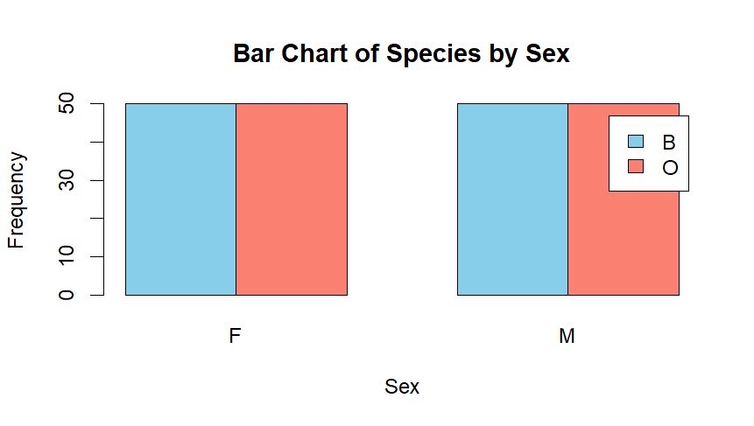
1e.
The crabs dataset is perfectly balanced across the four species–sex groups, with 50 observations in each group. This results in a balanced 2 × 2 factorial design, which is ideal for comparative and multivariate statistical analysis.

Question 2
2a.
# Load MASS package
library(MASS)

# Load dataset
data(crabs)

# Create combined group variable
crabs$group <- interaction(crabs$sp, crabs$sex)

# Side-by-side boxplots
boxplot(BD ~ group,
data = crabs,
col = c("skyblue", "lightgreen", "salmon", "orange"),
main = "Body Depth (BD) by Species and Sex",
xlab = "Species and Sex Groups",
ylab = "Body Depth (mm)")
OUTPUT:
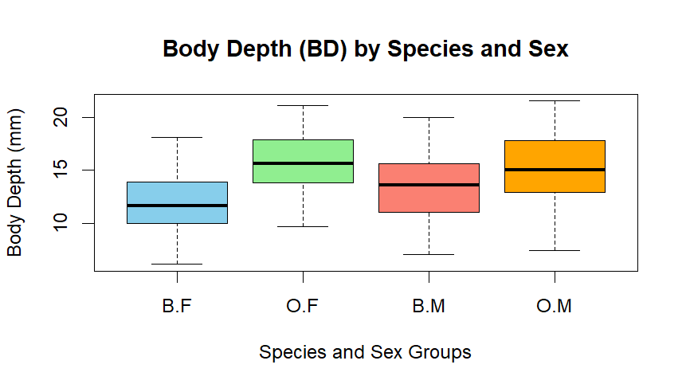
2b.
The side-by-side boxplots show minimal evidence of extreme outliers across the four species–sex groups. The median body depth is higher for males than females in both species, indicating a strong sex effect. Differences between species are less pronounced than differences between sexes. The interquartile ranges are similar across groups, although male groups exhibit slightly greater variability. Overall, body depth appears more strongly associated with sex than species.

Question 3
3a.
# Load MASS package
library(MASS)

# Load dataset
data(crabs)

# Set plotting area for side-by-side plots
par(mfrow = c(1, 2))

# Histogram for Blue species
hist(crabs$CL[crabs$sp == "B"],
main = "Histogram of CL (Blue Species)",
xlab = "Carapace Length (mm)",
col = "skyblue",
border = "black")

# Histogram for Orange species
hist(crabs$CL[crabs$sp == "O"],
main = "Histogram of CL (Orange Species)",
xlab = "Carapace Length (mm)",
col = "salmon",
border = "black")

# Reset plotting area
par(mfrow = c(1, 1))
OUTPUT:
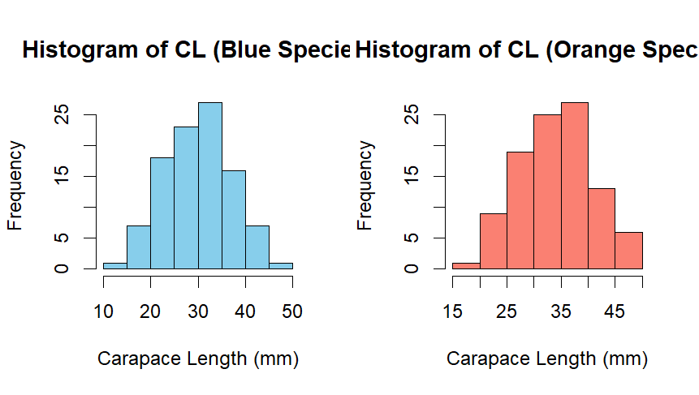
3b.
The histograms of carapace length for both Blue and Orange species are approximately symmetric and roughly bell-shaped, suggesting near-normal distributions. There is no strong evidence of skewness in either species. However, mild bimodality may be observed, which is likely attributable to the inclusion of both male and female crabs within each species. Overall, the shapes of the two species distributions are very similar.

QUESTION 4
4a.
library(dplyr)

crabs %>%
group_by(sp, sex) %>%
summarise(across(c(FL, RW, CL, CW, BD), mean), .groups = "drop")

output:
> crabs %>%
+ group_by(sp, sex) %>%
+ summarise(across(c(FL, RW, CL, CW, BD), mean), .groups = "drop")
# A tibble: 4 × 7
sp sex FL RW CL CW BD
<fct> <fct> <dbl> <dbl> <dbl> <dbl> <dbl>
1 B F 13.3 12.1 28.1 32.6 11.8
2 B M 14.8 11.7 32.0 36.8 13.4
3 O F 17.6 14.8 34.6 39.0 15.6
4 O M 16.6 12.3 33.7 37.2 15.3

4b.
# Load MASS package
library(MASS)

# Load dataset
data(crabs)

# Compute group means
means <- aggregate(cbind(FL, RW, CL, CW, BD) ~ sp + sex,
data = crabs,
FUN = mean)

# Create group labels
means$group <- paste(means$sp, means$sex, sep = ".")

# Create matrix of means (rows = measurements, columns = groups)
mean_matrix <- t(as.matrix(means[, 3:7]))
colnames(mean_matrix) <- means$group

# Grouped bar chart
barplot(mean_matrix,
beside = TRUE,
col = c("skyblue", "salmon", "lightgreen", "orange", "purple"),
legend.text = rownames(mean_matrix),
args.legend = list(x = "topright"),
main = "Mean Morphological Measurements by Species and Sex",
xlab = "Species and Sex Groups",
ylab = "Mean Value")

OUTPUT:
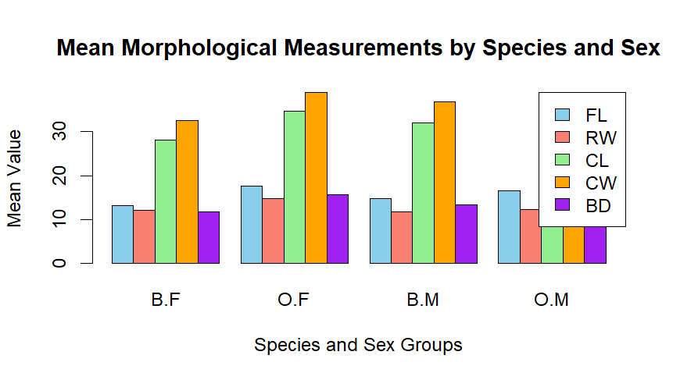

4c.
library(MASS)
library(dplyr)

data(crabs)

# Compute means by species and sex
means <- crabs %>%
group_by(sp, sex) %>%
summarise(across(c(FL, RW, CL, CW, BD), mean), .groups = "drop")

means
output:
# A tibble: 4 × 7
sp sex FL RW CL CW BD
<fct> <fct> <dbl> <dbl> <dbl> <dbl> <dbl>
1 B F 13.3 12.1 28.1 32.6 11.8
2 B M 14.8 11.7 32.0 36.8 13.4
3 O F 17.6 14.8 34.6 39.0 15.6
4 O M 16.6 12.3 33.7 37.2 15.3

>

Species differences (averaging over sex)
species_means <- crabs %>%
group_by(sp) %>%
summarise(across(c(FL, RW, CL, CW, BD), mean))

species_diff <- abs(species_means[1, -1] - species_means[2, -1])
species_diff
output:
FL RW CL CW BD
1 3.054 1.621 4.095 3.395 2.895

Sex difference(averaging over species)

sex_means <- crabs %>%
group_by(sex) %>%
summarise(across(c(FL, RW, CL, CW, BD), mean))

sex_diff <- abs(sex_means[1, -1] - sex_means[2, -1])
sex_diff

output:
FL RW CL CW BD
1 0.302 1.497 1.491 1.169 0.613

Answer:
Carapace Width (CW) exhibits the greatest difference between species, indicating it is most sensitive to species variation. Frontal Lobe (FL) shows the least variation between sexes, suggesting that sexual dimorphism has the smallest effect on this measurement compared to the others.

Question 5
5a.
# Define colours by species
cols <- ifelse(crabs$sp == "B", "skyblue", "salmon")

pairs(measurements,
main = "Scatterplot Matrix by Species",
pch = 19,
col = cols)
output:


